Beschreibung: JMH Logo sw_300A Place of Our Own

**Four Young Palestinian Women in Tel Aviv**  
by Iris Hassid, Mai7, 2023 until March 10, 2024

Publication

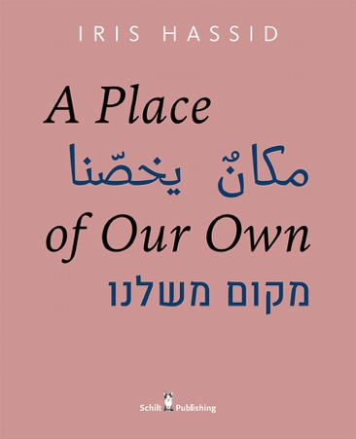Edition in English/Hebrew/Arabic  
Ed. Victor Levie & Iris Hassid   
Design: Victor Levie, Levievandermeer, Amsterdam 2020 Schilt Publishing & Gallery, Amsterdam   
Format: 24 x 29,5 cm | Hardcover with dust jacket  
168 pp with 90 photos in full color | € 45,-  
ISBN 978 90 5330 943 8

For six years (2014-2020) Tel Aviv-based photographer and artist Iris Hassid followed the day to day life of four young Palestinian women, citizens of Israel, who are part of a recent surge of the young generation of Arab female students attending Tel Aviv University.

Engaging in spontaneous, pleasurable, and often thought-provoking conversations, Iris Hassid photographed Samar (a fresh graduate from film school) from Nazareth, her cousin Saja (studying psychology) also from Nazareth, Majdoleen (studying architecture) from Kafr Kanna, and Aya (studying social work and gender studies), from Kafr Qara. One can see bits of these conversations in the book.

“It was refreshing to hear Arabic being spoken in my neighborhood by a new generation of young and self-confident women, so different from how they are portrayed in the media. Why do we label people by their languages, names, accents, looks, and nationalities?” The presence of these young women in Ramat Aviv fascinated Iris Hassid, who lives right around the corner from Tel Aviv University, so it made sense to engage. “This project does not claim to faithfully document the lives of these women, nor does it pretend to show ‘true’ moments. It should be seen as a collaboration between them and me.

The outcome of the project is as refreshing, remarkable, and hopeful as it is unclear. “I gained their trust as we learned more about each other. Bit by bit I witnessed more intimate parts of their lives and I also met their families back home. This long and intimate collaboration made me question the place I live in, the historical narrative, the identity and symbols we inherited on both sides. It has revealed a complex and new reality. I often think about their futures and about the future of this country.”